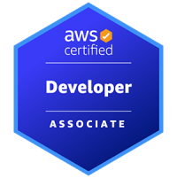
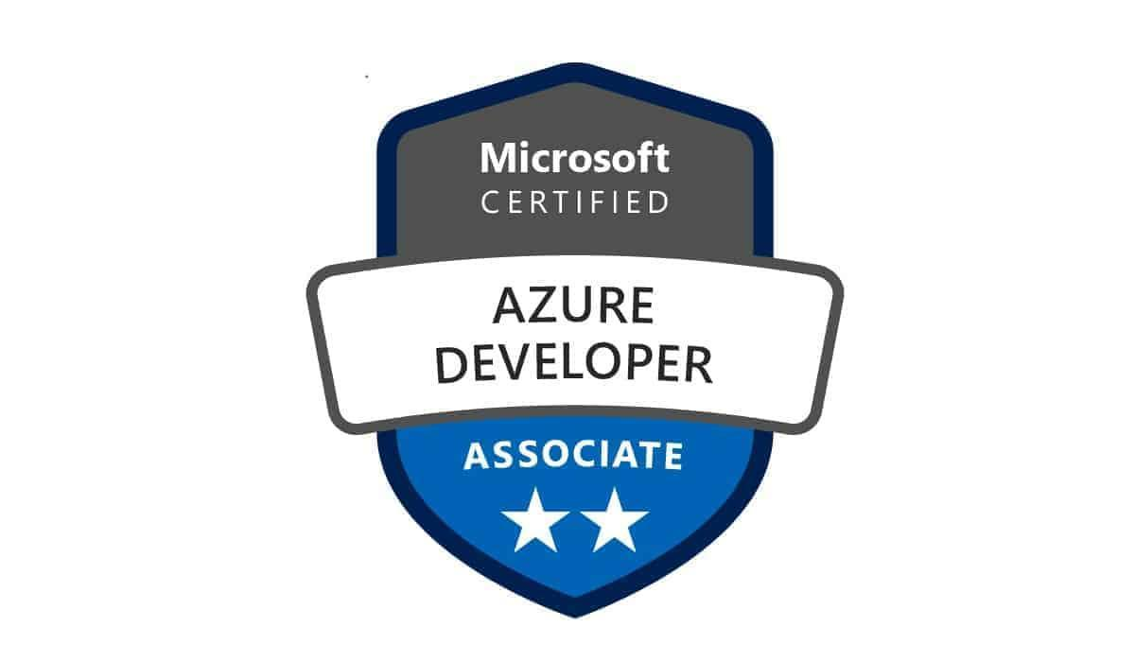
Name: shreyank B
Senior Python Developer
Email: shreyank0417@gmail.com
Phone: 682-463-4175
Linkedin

Professional Summary:

- Senior Python Developer with 10+ years of experience designing and building scalable backend systems, APIs, real-time data applications and distributed services across AWS, Azure and GCP environments.
- Expert in Python programming with deep understanding of OOP, design patterns, asynchronous programming (asyncio, concurrent.futures), decorators and exception handling.
- Designed and developed secure RESTful and gRPC APIs using FastAPI, Flask, Django and Google API Gateway, with JWT, OAuth2 and OIDC-based authentication and role-based access control.
- Built event-driven microservices using Apache Kafka, Redpanda, Amazon Kinesis, Google Pub/Sub, Azure Event Grid and Apache Pulsar, integrating producers/consumers using confluent-kafka, aiokafka and custom Python scripts.
- Developed modular ETL/ELT workflows using PySpark, dbt, Apache NiFi, Airbyte, Informatica, Matillion and Apache Sqoop, with schema validation using Pydantic and Marshmallow.
- Created batch and streaming data pipelines using Apache Spark, Ray, Dask, Apache Flink and Spark SQL, embedding transformation logic in testable, reusable Python components.
- Orchestrated automated workflows with Airflow, Cloud Composer, Dagster and Google Dataflow, writing custom Python operators and alerting mechanisms.
- Integrated and deployed machine learning models using MLflow, Databricks, SageMaker, Vertex AI, Azure ML, Kubeflow, Feast, Tecton and Seldon Core for real-time inference and model versioning.
- Built data ingestion and processing pipelines on Delta Lake, Iceberg, Snowflake, BigQuery, Redshift, ClickHouse, Azure Synapse and Google Cloud Spanner using Python wrappers and connectors.
- Developed business and monitoring dashboards using Looker, Power BI, Tableau, Apache Superset, Amazon QuickSight, Grafana, Kibana, Redash, Metabase and Matplotlib, with backend integration in Python.
- Packaged Python microservices using Docker and deployed them to Kubernetes (EKS, AKS, GKE) using Helm, Kustomize and OpenShift, managing service discovery and scaling.
- Automated infrastructure provisioning and configuration using Terraform, Pulumi, AWS CDK, Google Config Connector, Azure ARM, CloudFormation, Ansible and Chef, often integrated with Python scripting for dynamic logic.
- Built CI/CD pipelines using GitHub Actions, GitLab CI/CD, Jenkins, Jenkins X, Azure Pipelines, Cloud Build, Spinnaker, Bitbucket and Argo Workflows, running automated tests and deployments for Python services.
- Applied TDD practices using pytest, unittest and tox, with mocking libraries like moto and enforced quality via flake8, black, mypy and bandit for secure and compliant Python code.
- Secured cloud-native applications using AWS IAM, Azure IAM, Google Secret Manager, AWS Secrets Manager, HashiCorp Vault, KMS and policy enforcement via OPA/Gatekeeper.
- Developed backend logic for data validation, enrichment and anomaly detection using Pandas, NumPy, SciPy, Great Expectations and Python-based statistical methods.
- Integrated asynchronous and distributed task execution using Celery, asyncio and Cloud Tasks, improving responsiveness and throughput of time-sensitive services.
- Instrumented monitoring, alerting and logging with Datadog, Prometheus, Grafana, Loki, OpenTelemetry, CloudWatch, Azure Monitor, Splunk, ELK/EFK and Sentry, with custom Python exporters and structured logs.
- Worked with code and data versioning tools including LakeFS, Dolt, JupyterHub and VS Code Remote, enabling reproducible experiments and collaborative development.
- Strong multi-language foundation with hands-on coding in Python, SQL, Scala, Java, Go, Rust and Bash, with Python as the core language across all infrastructure, data and application layers.

Employment History:

Client: Valley Bank |Morristown, NJ| Duration: Dec 2023 - Till Date
Senior Python Developer

Core Project Tasks:
- Designed and developed modular, object-oriented Python applications to orchestrate real-time and batch data pipelines, applying patterns like factory and strategy to build scalable, maintainable codebases.
- Engineered distributed ETL pipelines using PySpark on AWS EMR, optimizing memory usage and parallelism to reduce processing latency by 40% across large financial datasets.
- Refactored legacy systems into microservices using Flask, FastAPI, and AWS Lambda, improving deployment speed, scalability, and fault isolation in critical financial transaction workflows.
- Built asynchronous, event-driven services using AWS Kinesis, Kafka, and SQS/SNS, enabling responsive behavior and real-time alerting in fraud detection and compliance engines.
- Created robust data models and schema validation layers using SQLAlchemy, Pydantic, and Marshmallow, supporting structured ingestion from DynamoDB, Oracle, and S3.
- Developed reusable Python ingestion modules for structured and semi-structured data (CSV, JSON, XML), embedding logging, schema validation, and error handling through decorators.
- Automated end-to-end ETL/ELT workflows using AWS Glue, dbt, and Apache Airflow, integrating memory profiling and concurrency control via asyncio and multiprocessing.
- Implemented scalable APIs using FastAPI and Uvicorn, with OpenAPI-compliant documentation, middleware-based rate limiting, and structured exception handling.
- Enabled full observability via AWS CloudWatch, ELK, and Prometheus, embedding contextual logging and JSON log formatting into all core Python services.
- Built statistical data quality and validation checks using Pandas, SciPy, and Great Expectations, wrapping reusable logic into internal Python libraries.
- Developed preprocessing pipelines for ML workloads using Scikit-learn, SageMaker SDK, and joblib, enabling real-time model triggers and anomaly detection.
- Managed infrastructure as code using Terraform, automating environment provisioning and policy validation through custom Python validators.
- Created CI/CD workflows using GitHub Actions and Jenkins, integrating linting (flake8, black), testing, containerization, and automated deployment of Python services to AWS.
- Deployed high-throughput, containerized applications using Docker, AWS Fargate, and ECS, reducing cold start time and enhancing cost efficiency for microservices.
- Mentored junior developers in Python architecture, code debugging, testing strategies, and cloud-native service development, driving best practices across engineering teams.

Client: Mckesson Corporation |Irving, TX| Duration: July 2020 - Nov 2023
Senior Python Developer

Core Project Tasks:
- Built large-scale batch and real-time data pipelines using PySpark, Apache Spark, and AWS EMR, encapsulating business logic in modular Python functions with decorators and custom exception classes.
- Designed real-time event processing systems using Kinesis Data Streams, Firehose, and Lambda, with asynchronous orchestration via asyncio and concurrent.futures to handle device telemetry and clinical event flows.
- Established a centralized data lake architecture on Amazon S3, automating ingestion, partitioning, and metadata tagging using boto3, lifecycle policies, and Python scripts.
- Developed robust ETL/ELT workflows with AWS Glue, Apache Airflow, and Redshift, integrating transformation logic with pytest, PEP8-compliant code, and dynamic schema handling.
- Created RESTful APIs using FastAPI and Flask to expose analytics results, health status, and job metadata with JWT authentication and RBAC controls for internal stakeholders.
- Containerized Python services with Docker, deploying to Amazon EKS, and managing configuration, startup health checks, and environment isolation through custom entry scripts.
- Provisioned infrastructure using Terraform and CloudFormation, with supporting Python automation scripts for secrets rotation, policy enforcement, and deployment validation.
- Integrated secure external data sources using IAM, Secrets Manager, and KMS, implementing token refresh logic and structured logging via Python’s logging module and JSON formatters.
- Built reusable validation libraries using Pandas, NumPy, and Great Expectations, generating dynamic checks and validation reports across multiple pipeline stages.
- Enabled observability through CloudWatch, CloudTrail, and the Slack API, writing Python scripts for custom metric tracking, anomaly detection, and proactive alerting.
- Deployed ML pipelines using Amazon SageMaker, leveraging Scikit-learn, joblib, and Pandas for feature engineering, training, evaluation, and batch inference integration.
- Designed fault-tolerant orchestration workflows using AWS Step Functions and EventBridge, with idempotent Python handlers for event retries and failure recovery.
- Automated CI/CD processes using AWS CodePipeline, CodeBuild, embedding Python linting (flake8, black), unit tests, and environment-variable injection.
- Authored technical documentation using Sphinx and MkDocs, covering pipeline logic, architecture, onboarding, and API contract definitions for cross-team alignment.
- Supported data governance with Python scripts enforcing KMS encryption, tracking user activity via CloudTrail, and surfacing audit trails for compliance readiness in clinical systems.

Client: venmo |New York, NY| Duration: May 2018 - Jun 2020
Python Developer

Core Project Tasks:
- Developed modular Python-based ETL workflows and reporting APIs by collaborating with data scientists and analysts, integrating outputs into Azure Power BI, Kibana, and custom dashboards.
- Engineered scalable data ingestion pipelines using Kafka, Apache NiFi, and Azure Event Hubs, building class-based Python producers/consumers to support real-time and batch flows across financial systems.
- Designed and optimized Azure SQL and MySQL schemas, automating migrations, indexing strategies, and analytics workflows using SQLAlchemy and custom Python utilities.
- Built distributed data warehouses on Azure Synapse Analytics and Snowflake, automating table modeling and partitioned data movement using Python-based orchestration tools.
- Implemented ETL pipelines with PySpark, Azure Data Factory, and Spark SQL, encapsulating transformation logic with performance monitoring and structured logging.
- Developed REST APIs using Flask and FastAPI to expose job metadata, logs, and analytics, using Pydantic for validation and Swagger/OpenAPI for interactive documentation.
- Automated infrastructure provisioning using Terraform and ARM templates, integrating with Azure Key Vault and Python scripts for secure secret rotation and environment validation.
- Deployed containerized microservices using Docker and Kubernetes on AKS, writing Python-based readiness probes, config managers, and deployment lifecycle utilities.
- Managed ML workflows in Azure ML and Databricks, using Python to build feature extractors, evaluators, and training pipelines with MLflow and Delta Lake for tracking and reproducibility.
- Implemented NLP-based analytics using SpaCy, NLTK, and Python-based scoring models to extract intent, detect anomalies, and classify text in support tickets and transaction logs.
- Designed and embedded data validation routines using Pandas, NumPy, and rule-based Python scripts to ensure schema compatibility, trigger anomaly alerts, and track data lineage.
- Integrated observability into pipelines via Azure Monitor and Log Analytics, building Python agents to stream logs, metrics, and alerts in JSON for downstream correlation and root cause analysis.
- Automated CI/CD workflows with Azure DevOps, GitHub, and Bitbucket, embedding Python-based test suites, linting tools (flake8, black), and Docker packaging.
- Created visual analytics using Matplotlib and Python-enhanced Power BI dashboards, enabling dynamic aggregations, drill-downs, and EDA views for internal analytics consumers.
- Mentored junior developers on Python engineering best practices—OOP, error handling, decorators, and performance profiling with cProfile and line_profiler.

Client: Pacific Life |Newport Beach, CA| Duration: Oct 2016 - Apr 2018
Python Developer

Core Project Tasks:
- Collaborated with analysts, data scientists and stakeholders to define ingestion requirements, KPIs and reporting workflows, building Python-based orchestration and monitoring tools for data pipelines integrated with Looker, BigQuery and Google Dataflow.
- Engineered scalable ETL/ELT pipelines using Apache Spark (PySpark, Spark SQL) on Google Dataproc, refactoring transformation logic into Python classes and decorators for improved modularity and reduced processing latency by 40%.
- Architected data warehouse solutions using BigQuery and Google Cloud Spanner, automating schema deployment and partitioning strategies via Python scripts and Jinja2 templates, boosting query performance by over 50%.
- Built streaming ingestion systems with Google Pub/Sub, Apache Kafka and Cloud Tasks, designing custom Python consumers leveraging asyncio, aiohttp and message buffering for real-time event processing.
- Managed schema evolution and data validation using Apache NiFi, Google Dataflow and Cloud Functions, with Python handlers for dynamic schema mapping and validation using Pydantic and Marshmallow.
- Developed interactive dashboards and real-time analytics visualizations using Looker, Matplotlib and dbt, with backend aggregation logic implemented in Python to serve API endpoints and export-ready data views.
- Designed logical and physical data models across BigQuery and Cloud SQL (PostgreSQL, MySQL, Oracle DB), using Python ORM libraries like SQLAlchemy to enforce constraints and optimize query composition.
- Automated batch and streaming transformations with Cloud Composer, Google Dataflow and dbt, embedding Python-based control mechanisms for DAG reliability, failure recovery and task parameterization.
- Integrated ML pipelines into production workflows using Databricks, Delta Lake and Python, applying scikit-learn, joblib and model versioning strategies for reproducibility and real-time inference.
- Developed secure RESTful APIs using Flask, FastAPI and Django, incorporating request validation with Pydantic, exception handling middleware and JWT-based authentication layers via Google API Gateway.
- Deployed and managed containerized services using Docker, Kubernetes and Google Kubernetes Engine (GKE), scripting Helm chart configurations and custom init containers using Python for seamless deployment flows.
- Established CI/CD pipelines with Cloud Build, Cloud Deploy and Cloud Source Repositories, embedding automated Python testing (pytest, unittest) and linting (flake8, black) into deployment stages.
- Enhanced system observability with Datadog, Google Cloud Monitoring and Celery, developing Python agents for log aggregation, job tracking and anomaly detection using statistical thresholds.
- Implemented robust logging, tracing and metrics collection using Google Cloud Logging, Elasticsearch and Cloud Trace, wrapping critical pipeline stages with custom decorators for execution tracing.
- Created Python batch-processing scripts and PySpark jobs to support large-scale data transformations, embedding retry logic, memory optimization and concurrent execution via multiprocessing and threading modules.
- Authored detailed technical documentation using Sphinx and MkDocs, outlining data flows, transformation logic, REST API contracts and deployment steps for efficient onboarding and system maintainability.
- Provided production support for real-time and batch workflows, writing Python utilities for SLA monitoring, failure alerting and automated rollbacks in the event of data or schema mismatches.

Client: The Cigna Group |Bloomfield, CT| Duration:-Nov 2013 - Sep 2016
Python Developer

Core Project Tasks:
- Engineered scalable big data processing frameworks using Apache Spark, Apache Hadoop and Apache Flink, encapsulating transformation logic into reusable Python classes and functions to convert raw data into analytics-ready formats.
- Built and optimized a cloud-native data warehouse using Snowflake, with schema evolution and performance tuning automated through Python-based orchestration scripts leveraging Snowflake Python Connector and dbt.
- Managed and tuned high-volume Oracle databases using cx_Oracle and custom SQL optimization scripts in Python, implementing dynamic indexing and caching for sub-second transactional query access.
- Designed real-time streaming pipelines using Apache Kafka, Spark Streaming and Apache Flink, developing Python-based Kafka consumers and producers using confluent-kafka and applying asyncio for concurrency control.
- Automated ETL orchestration using dbt, Informatica and Python, applying decorators and exception-handling wrappers to ensure modularity, reusability and fault tolerance in data workflows.
- Developed secure RESTful APIs with Flask, implementing structured request validation using Pydantic, JWT-based authentication and OpenAPI documentation via Flasgger for seamless integration with internal and external consumers.
- Created Python-based data loaders and enrichment services to support interactive dashboards built in Tableau and Power BI, enabling real-time visualization of KPIs and business metrics.
- Deployed and managed containerized microservices using Docker and Kubernetes, writing Python startup scripts, health checks and container lifecycle handlers for scalable and resilient workloads.
- Provisioned infrastructure using Terraform and AWS CloudFormation, integrating Python automation scripts to validate configurations, rotate secrets and ensure environment consistency.
- Implemented CI/CD pipelines with Jenkins, using Python scripts for pre-deployment validation, integration testing (pytest) and post-deployment rollback mechanisms on failure detection.
- Scripted high-performance data ingestion, cleansing and enrichment routines in Python and Linux shell scripting, applying Pandas, NumPy and regular expressions for data normalization and transformation.
- Developed custom logging and monitoring tools in Python for Datadog, pushing performance metrics, system events and anomaly alerts through structured log handlers and webhook integrations.

Educational Background:

- Bachelors in computer science and engineering.

Training & Certifications:

- AWS Certified Developer Associate.
- Microsoft Certified Azure Developer Associate.
- Google Cloud Certified Professional Data Engineer.

